INTRODUCTION
1.1 Project Overview
The Heart Disease Analysis project aims to analyze and visualize heart disease patient data to identify important patterns, trends, and risk factors associated with cardiovascular diseases. Heart disease is one of the leading causes of death worldwide, and the healthcare industry generates a vast amount of patient data, including medical history, diagnostic reports, laboratory results, and lifestyle information. Analyzing this data manually is a complex and time-consuming process that often makes it difficult to identify meaningful insights. Therefore, database management and data visualization techniques are used to organize, analyze, and present the data in a simple, interactive, and easy-to-understand format.
This project utilizes a heart disease dataset obtained from reliable sources such as Kaggle. The dataset contains important patient attributes including age, gender, HeartDisease, BMI, Smoking, AlcoholDrinking, Stroke, PhysicalHealth, MentalHealth, DiffWalking, Sex, AgeCategory, Race, Diabetic, PhysicalActivity, SleepTime, Asthma, KidneyDisease, and SkinCancer. Before performing the analysis, the dataset undergoes preprocessing steps such as data cleaning, handling missing values, removing duplicate records, correcting inconsistencies, and organizing the data into a structured format using MySQL Workbench.
The project uses MySQL Workbench to create and manage the database, perform SQL queries, and analyze the patient information efficiently. SQL is used to retrieve meaningful insights by calculating averages, identifying trends, comparing patient groups, and examining relationships between different medical attributes and heart disease occurrence. After completing the analysis, the processed data is connected to Tableau, where interactive dashboards, charts, and graphs are created to present the findings visually. Various visualization techniques, including bar charts, pie charts, line charts, scatter plots, histograms, heat maps, and dashboards, are used to explore disease distribution, age-wise analysis, gender comparison, cholesterol levels, blood pressure trends, chest pain categories, and other health indicators.
The primary objective of this project is to help healthcare professionals, medical researchers, hospital administrators, students, and policymakers make informed decisions based on data-driven insights. By identifying the major risk factors associated with heart disease and understanding how different health conditions influence disease occurrence, users can improve early diagnosis, patient monitoring, preventive healthcare strategies, and clinical decision-making. The interactive Tableau dashboards allow users to filter and explore the data dynamically, making complex medical information easier to interpret and understand.

1.2 Purpose
The purpose of the Heart Disease Analysis using MySQL Workbench and Tableau project is to analyze healthcare data and present meaningful insights through effective database analysis and interactive data visualization techniques. The project aims to convert large and complex healthcare datasets into clear, organized, and easy-to-understand visual reports that help users identify patterns, trends, and relationships among various health and lifestyle factors associated with heart disease.
The project focuses on understanding the factors that influence the occurrence of heart disease by analyzing patient information such as HeartDisease, BMI, Smoking, AlcoholDrinking, Stroke, PhysicalHealth, MentalHealth, DiffWalking, Sex, AgeCategory, Race, Diabetic, PhysicalActivity, SleepTime, Asthma, KidneyDisease, and SkinCancer. By analyzing these factors, users can compare different patient groups, identify high-risk individuals, and understand how lifestyle habits, medical conditions, and demographic characteristics contribute to heart disease.
Another purpose of this project is to support data-driven decision-making for healthcare professionals, researchers, hospital administrators, public health organizations, and policymakers. Healthcare professionals can better understand patient risk factors, researchers can identify disease patterns, hospitals can improve patient care strategies, and policymakers can use the findings to develop effective public health awareness and prevention programs.
The project also serves as a practical application of database management and business intelligence concepts by utilizing MySQL Workbench for data storage, preprocessing, and SQL-based analysis, along with Tableau for creating interactive dashboards and visualizations. These tools help organize, analyze, and present healthcare data efficiently, making complex medical information easier to interpret and understand.
Additionally, the project aims to improve technical, analytical, and problem-solving skills by demonstrating the complete workflow of data analysis, including data collection, data preprocessing, database management, SQL querying, data visualization, and interpretation of results. It emphasizes the importance of transforming raw healthcare data into meaningful insights that can support better clinical decisions, healthcare planning, and disease prevention strategies.

IDEATION PHASE
2.1 Problem Statement
Heart disease is one of the leading causes of illness and death worldwide, making early identification of risk factors an important challenge for healthcare organizations. Hospitals and medical institutions generate large volumes of patient data every day, including information related to health conditions, lifestyle habits, and medical history. Analyzing this data manually is time-consuming, prone to errors, and often makes it difficult to identify meaningful patterns that can support timely diagnosis and effective treatment.
The purpose of the Heart Disease Analysis using MySQL Workbench and Tableau project is to analyze healthcare data and present meaningful insights through efficient database management and interactive data visualization techniques. The project aims to transform large and complex healthcare datasets into clear, organized, and easy-to-understand visual reports that help users identify trends, patterns, and relationships among different health and lifestyle factors associated with heart disease.
The project focuses on analyzing patient information such as HeartDisease, BMI, Smoking, AlcoholDrinking, Stroke, PhysicalHealth, MentalHealth, DiffWalking, Sex, AgeCategory, Race, Diabetic, PhysicalActivity, SleepTime, Asthma, KidneyDisease, and SkinCancer. By examining these factors, the project helps identify the characteristics that may increase the risk of heart disease and enables comparisons across different groups of patients.
Another objective of this project is to support data-driven decision-making for healthcare professionals, researchers, hospital administrators, and public health organizations. The insights generated through the analysis can assist medical experts in identifying high-risk individuals, understanding disease patterns, planning preventive healthcare programs, and improving patient care through evidence-based decisions.
The project also serves as a practical application of database management and business intelligence by using MySQL Workbench for data storage, preprocessing, and SQL-based analysis, and Tableau for creating interactive dashboards and visual reports. These tools simplify complex healthcare information and enable users to explore the data through dynamic charts, graphs, and filters.
Additionally, the project enhances analytical and technical skills by demonstrating the complete data analysis process, including data collection, preprocessing, database management, SQL querying, visualization, and interpretation of results. It emphasizes the importance of converting raw healthcare data into meaningful insights that support better clinical decisions, healthcare planning, and disease prevention strategies.
The healthcare sector generates a vast amount of patient data related to medical conditions, lifestyle habits, demographic information, and health indicators. However, this data is often stored in large databases that are difficult to interpret using traditional methods. As a result, healthcare professionals, researchers, and public health organizations face challenges in identifying disease patterns, recognizing risk factors, and making timely, data-driven decisions for patient care and disease prevention.
Heart disease is influenced by multiple factors such as HeartDisease, BMI, Smoking, AlcoholDrinking, Stroke, PhysicalHealth, MentalHealth, DiffWalking, Sex, AgeCategory, Race, Diabetic, PhysicalActivity, SleepTime, Asthma, KidneyDisease, and SkinCancer. Without proper analysis and visualization, it becomes difficult to understand how these factors are associated with heart disease or to identify patterns among different groups of patients. Manual analysis of large healthcare datasets is time-consuming, prone to errors, and often fails to reveal valuable insights that could support early diagnosis and effective treatment.
Another major challenge is the lack of clear and interactive visual representations that simplify complex healthcare data. Raw numerical records and database tables do not provide an intuitive understanding of disease trends, making it difficult for healthcare professionals and decision makers to compare patient groups, monitor health patterns, and recognize significant relationships among different health conditions.
This project addresses these challenges by analyzing heart disease data using MySQL Workbench and presenting the results through interactive Tableau visualizations such as bar charts, pie charts, line graphs, scatter plots, histograms, heat maps, and dashboards. These visual tools help identify relationships among different health factors, detect disease patterns, compare patient characteristics, and highlight important trends that may influence the occurrence of heart disease.
The objective of the project is to transform raw healthcare data into meaningful insights that support data-driven decision-making. By providing clear and interactive visual analysis, the project enables healthcare professionals, researchers, hospital administrators, and policymakers to better understand heart disease risk factors, improve patient care, develop preventive healthcare strategies, and make informed clinical and administrative decisions.
2.2 Empathy Map Canvas
Empathy Map Element | Details
User | Healthcare professionals, doctors, medical researchers, hospital administrators, public health organizations, and healthcare students.
Says | "I need accurate patient health insights." "Which factors increase the risk of heart disease?" "How can I identify high-risk patients?" "I want reliable data to support better healthcare decisions.”
Thinks | Wonders which health and lifestyle factors contribute most to heart disease, how patient characteristics are related to disease occurrence, and how data analysis can improve diagnosis, treatment, and prevention. Looks for accurate and trustworthy information to support clinical decisions.
Does | Collects patient data, analyzes medical records, performs SQL queries, reviews healthcare reports, studies disease trends, and uses dashboards to compare patient groups and monitor health patterns.
Feels | Concerned about identifying heart disease at an early stage, overwhelmed by large volumes of healthcare data, uncertain about hidden disease patterns, and motivated to improve patient care through data-driven insights.
Sees | Large healthcare databases, patient medical records, laboratory reports, health statistics, dashboards, charts, and reports showing disease trends and patient information.
Hears | Recommendations from healthcare experts, clinical guidelines, research findings, public health campaigns, patient feedback, and discussions about disease prevention and treatment strategies.
Pains | Difficulty analyzing large healthcare datasets, identifying hidden risk factors, interpreting complex medical information, limited visual representation of patient data, and time-consuming manual analysis.
Gains | Interactive dashboards, meaningful visual insights, faster identification of heart disease risk factors, improved patient monitoring, better clinical decision-making, enhanced healthcare planning, and support for preventive healthcare strategies.

2.3 Brainstorming
After evaluating different ideas, the project focuses on developing a healthcare data analysis and visualization system that transforms raw heart disease data into meaningful insights. The system analyzes patient health information, lifestyle factors, and medical conditions using database queries and interactive charts and dashboards. This approach simplifies complex healthcare datasets, improves understanding of heart disease patterns and risk factors, and supports better decision-making for healthcare professionals, researchers, and public health organizations.

REQUIREMENT ANALYSIS
3.1 Customer Journey map
Awareness → Data Access → Data Exploration → Visualization → Insight Generation → Decision Making → Feedback & Improvement

3.2 Solution Requirement
The Heart Disease Analysis using MySQL Workbench and Tableau project requires a reliable and efficient solution that can collect, store, process, analyze, and visualize healthcare data. The solution should help users understand patterns related to heart disease, identify important health risk factors, and generate meaningful insights through interactive dashboards and data-driven analysis. The system should provide an organized approach for managing patient data and presenting analytical results in a clear and understandable format.
Functional Requirements
1. Data Collection
- Import heart disease datasets from reliable sources such as Kaggle or CSV files.
- Support datasets containing patient health information, lifestyle factors, medical conditions, and demographic details.
- Ensure that collected data is suitable for database storage and analysis.
2. Data Preprocessing
- Handle missing values and duplicate records.
- Remove incorrect or inconsistent data entries.
- Convert raw healthcare data into a structured format for efficient analysis.
- Prepare clean and accurate data for SQL queries and visualization.
3. Data Storage and Management
- Create and manage a healthcare database using MySQL Workbench.
- Store patient records in organized database tables.
- Perform database operations such as inserting, updating, retrieving, and managing healthcare information.
4. Data Analysis
- Perform SQL queries to analyze patient health data.
- Calculate summary information and identify important patterns.
- Analyze relationships between health conditions, lifestyle factors, and heart disease occurrence.
- Identify trends and risk factors associated with heart disease.
5. Data Visualization
- Connect analyzed data with Tableau for visualization.
- Generate interactive charts, graphs, dashboards, and reports.
- Use visualization techniques such as bar charts, pie charts, line graphs, scatter plots, histograms, heat maps, and comparison charts.
- Display healthcare insights in a simple and understandable format.
6. Filtering and Comparison
- Allow users to filter data based on different patient characteristics and health conditions.
- Compare heart disease patterns among different groups of patients.
- Explore relationships between various factors affecting heart disease.
7. Reporting
- Present analytical findings through interactive Tableau dashboards.
- Provide visual summaries of heart disease trends and risk factors.
- Generate reports that support healthcare analysis and decision-making.
- Enable users to use insights for future healthcare planning and research.
3.3 Data Flow Diagram
[Start]
↓
[1. Collect Patient Data]
↓
[2. Store Data in MySQL Workbench]
↓
[3. Data Cleaning & Preprocessing]
↓
[4. SQL Analysis]
↓
[5. Visualize in Tableau]
↓
[6. Generate Insights & Reports]
↓
[7. End]
3.4 Technology Stack
┌─────────────────────┐
│ Data Source │
│ CSV / Excel Files │
└──────────┬──────────┘
│
▼
┌─────────────────────┐
│ MySQL Workbench │
│ Database + Storage │
└──────────┬──────────┘
│
▼
┌─────────────────────┐
│ Python │
│ Pandas + NumPy │
│ Data Cleaning │
└──────────┬──────────┘
│
▼
┌─────────────────────┐
│ SQL Analysis │
│ Queries + Trends │
└──────────┬──────────┘
│
▼
┌─────────────────────┐
│ Tableau │
│ Visualization + │
│ Dashboard │
└──────────┬──────────┘
│
▼
┌─────────────────────┐
│ Insights & Reports │
│ For Doctors │
└─────────────────────┘
PROJECT DESIGN
4.1 Problem Solution Fit & 4.2 Proposed Solution
Problem | Proposed Solution | Expected Benefit
Large healthcare datasets are difficult to understand and analyze. | Clean, organize, and preprocess heart disease data before analysis. | Simplifies healthcare data and improves analysis accuracy.
Raw patient data does not clearly show heart disease patterns and trends. | Visualize healthcare data using Tableau charts, graphs, heat maps, and interactive dashboards. | Makes disease trends and patterns easier to understand.
It is difficult to identify the factors associated with heart disease. | Perform SQL-based data analysis to examine relationships between health conditions, lifestyle factors, and heart disease occurrence. | Helps identify important risk factors and health patterns.
Users struggle to compare heart disease cases among different patient groups. | Provide filtering and comparison features through Tableau dashboards. | Enables easy comparison of patient groups and disease trends.
Manual analysis of healthcare records is time-consuming and prone to errors. | Automate data processing, analysis, and visualization using MySQL Workbench and Tableau. | Saves time and improves efficiency of healthcare data analysis.
Healthcare professionals lack clear insights for making informed decisions. | Generate interactive dashboards and analytical reports with meaningful healthcare insights. | Supports better decision-making, patient care, and preventive strategies.
Predicting future market behavior is challenging. | Prepare the system for future integration with advanced analytics and machine learning models. | Enables future risk prediction and improved healthcare planning.

4.3 Solution Architecture
The proposed Solution Architecture provides a structured framework for transforming raw housing data into actionable insights. By integrating data preprocessing, analysis, visualization, and reporting, the system delivers a comprehensive platform for understanding housing market trends and enables users to make informed real estate decisions.
PROJECT PLANNING & SCHEDULING
5.1 Project Planning
Task | Duration
Requirement Analysis | 1 Week
Data Collection | 1 Week
Data Preprocessing | 1 Week
Exploratory Data Analysis | 1 Week
Data Visualization | 2 Weeks
Dashboard Development | 1 Week
Testing and Validation | 1 Week
Documentation and Final Submission | 1 Week

FUNCTIONAL AND PERFORMANCE TESTING
6.1 Performance Testing
Metric | Target | Observed Result
Data Loading Time | Less than 5 seconds | Approximately 2–3 seconds
Data Preprocessing Time | Less than 10 seconds | Approximately 5–7 seconds
SQL Query Execution Time | Less than 3 seconds | Approximately 1–2 seconds
Dashboard Response Time | Less than 2 seconds | Approximately 1 second
Memory Usage | Efficient utilization | Stable during testing
System Availability | 99% or higher | Successfully maintained during testing

RESULTS
7.1 Output Screenshots
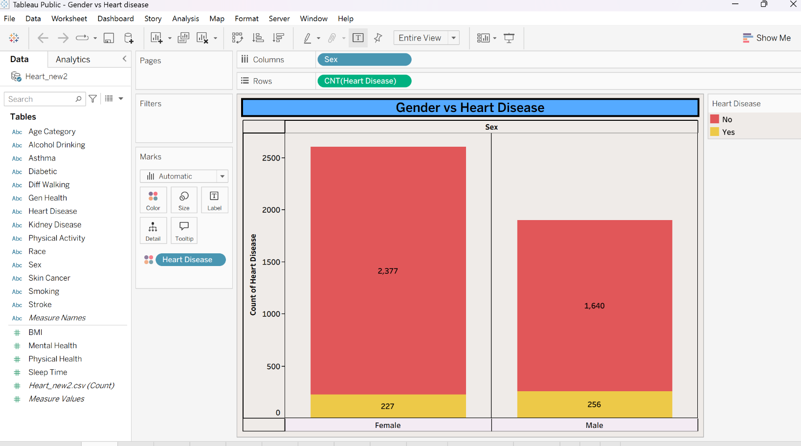
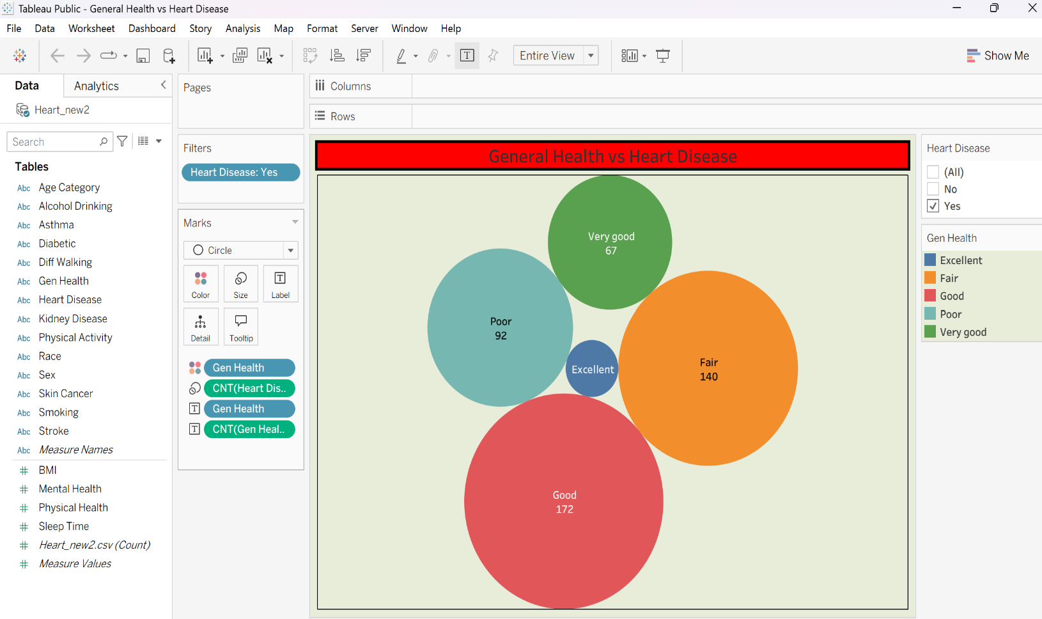
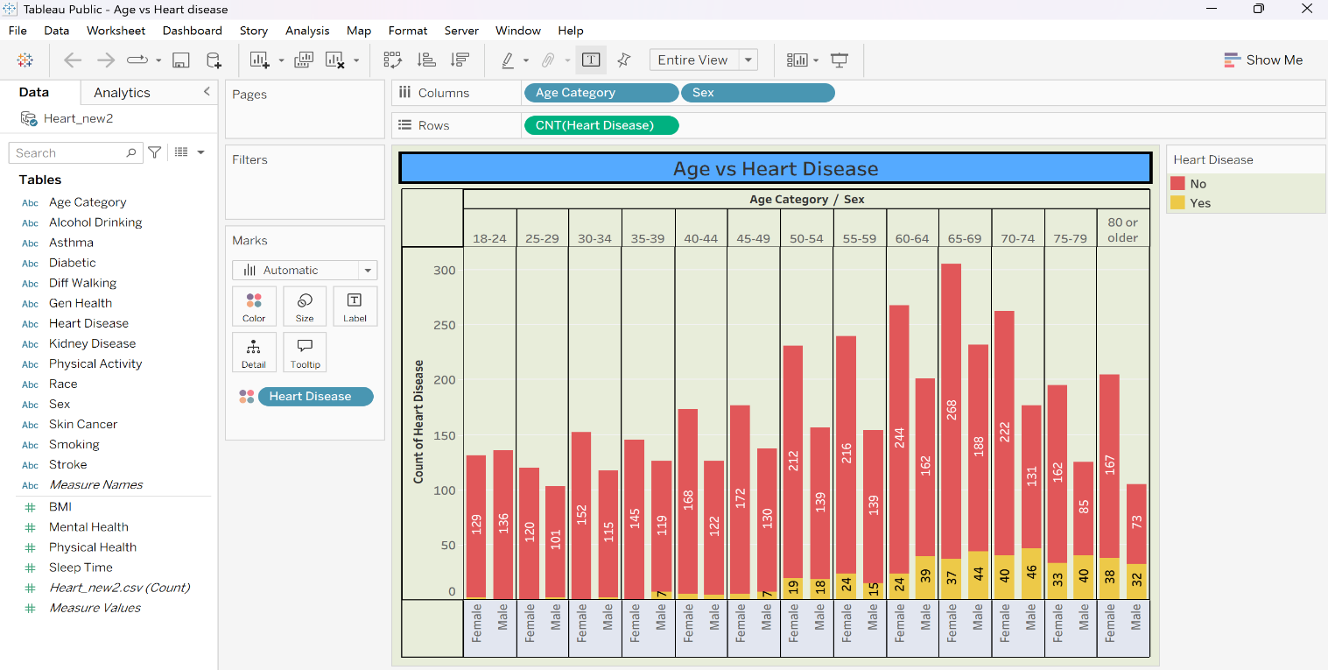
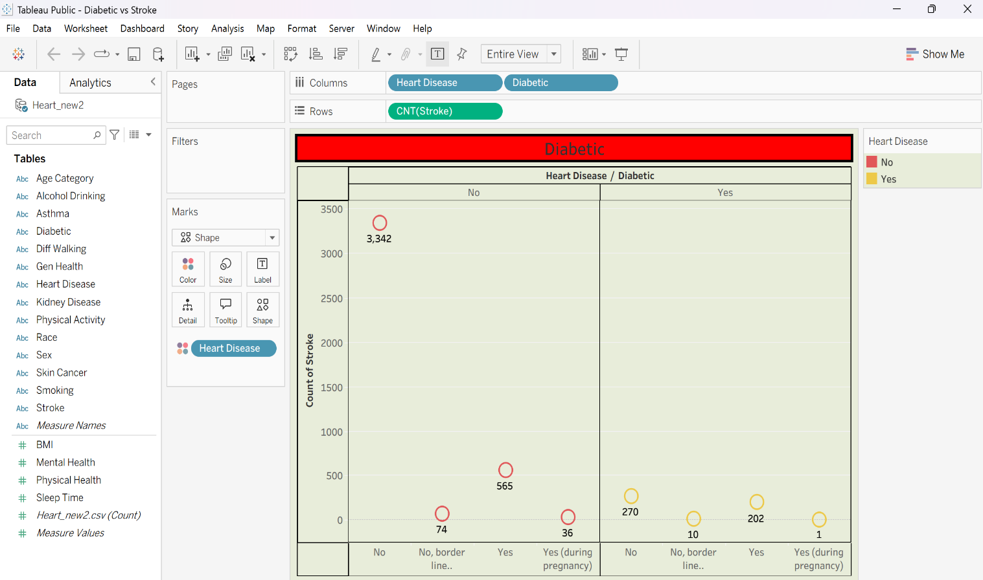
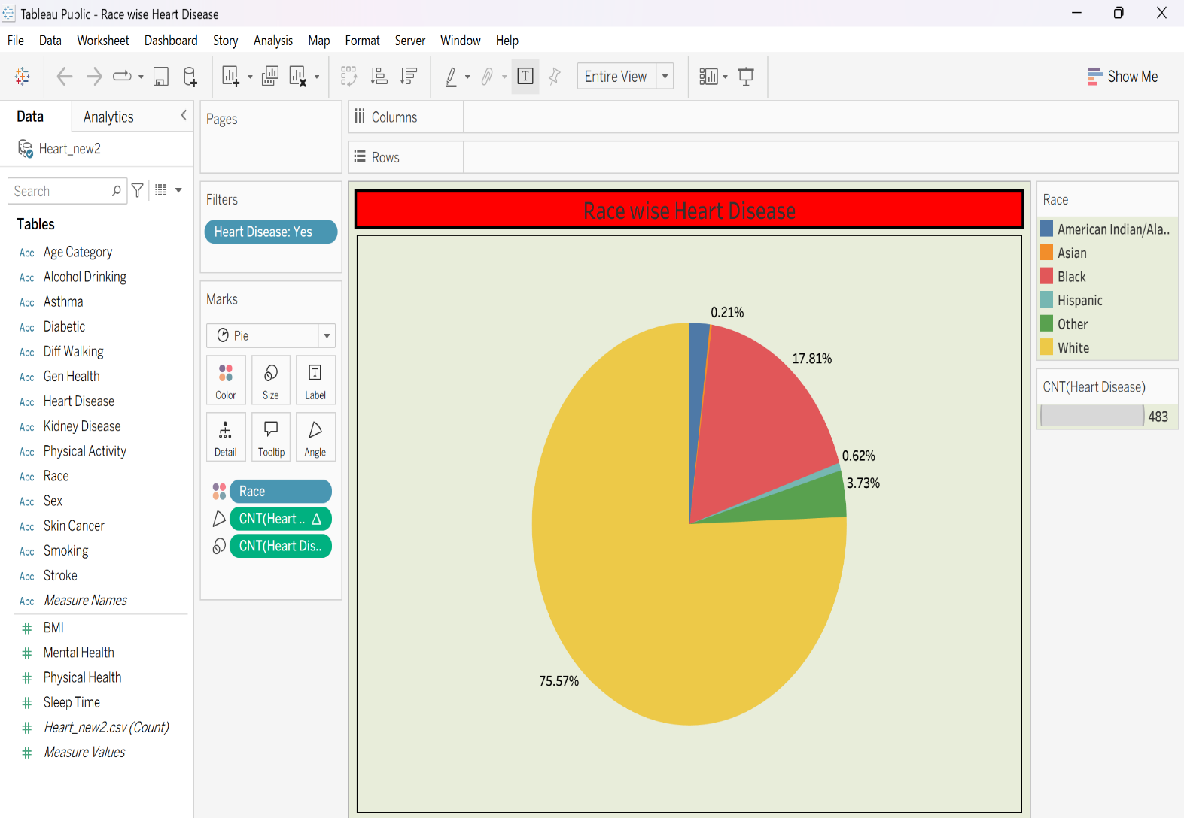
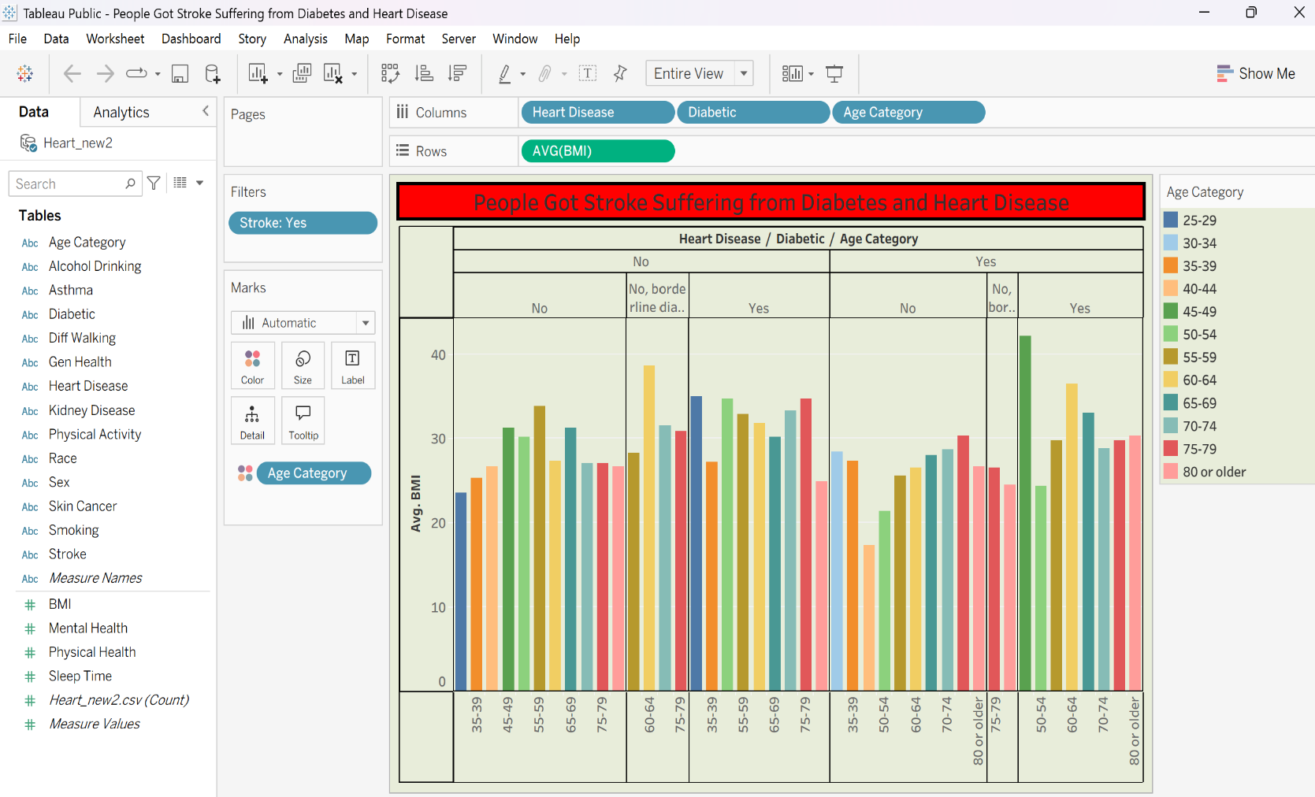
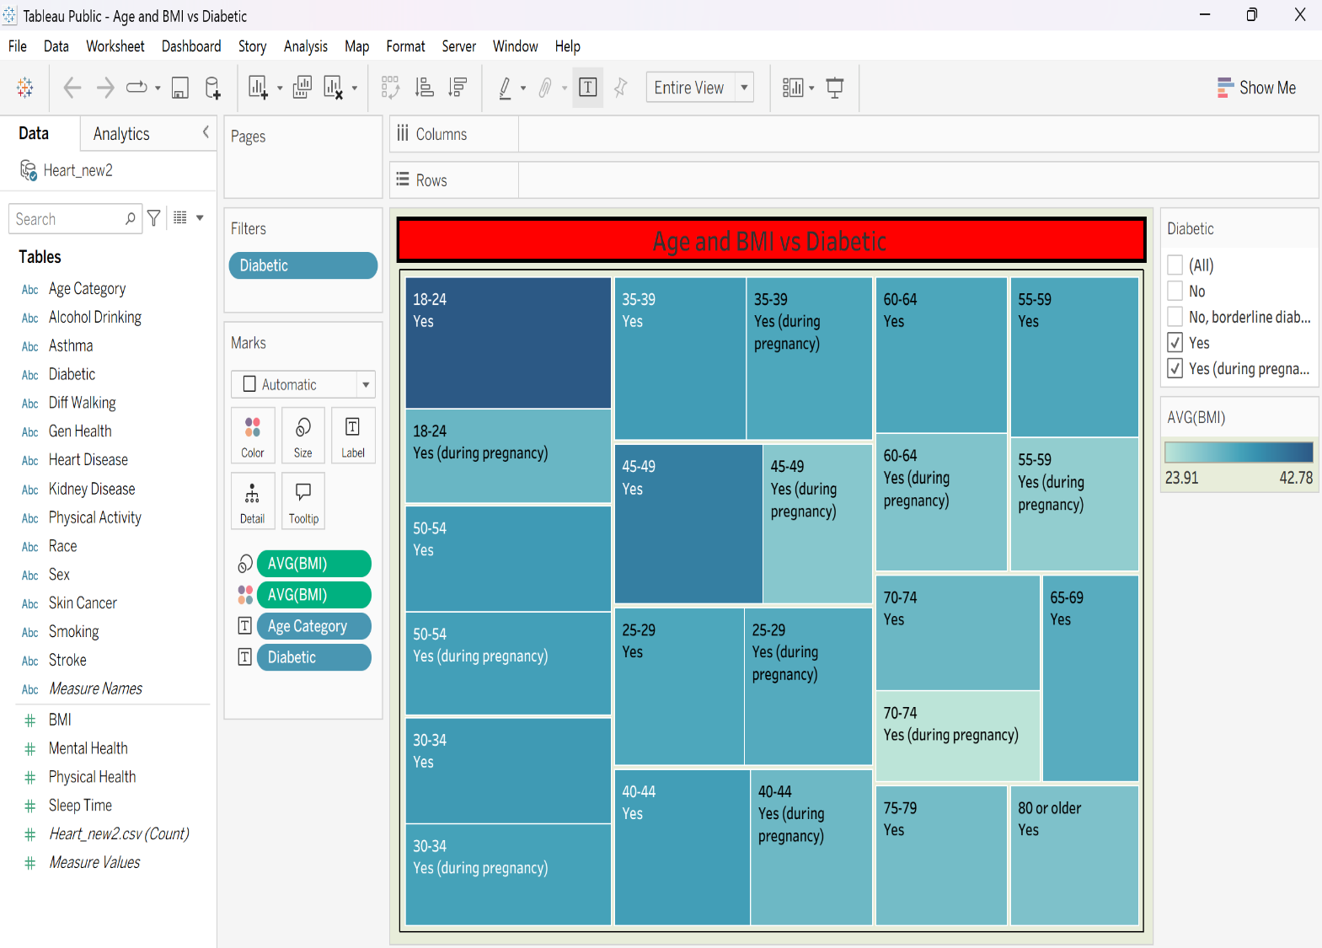
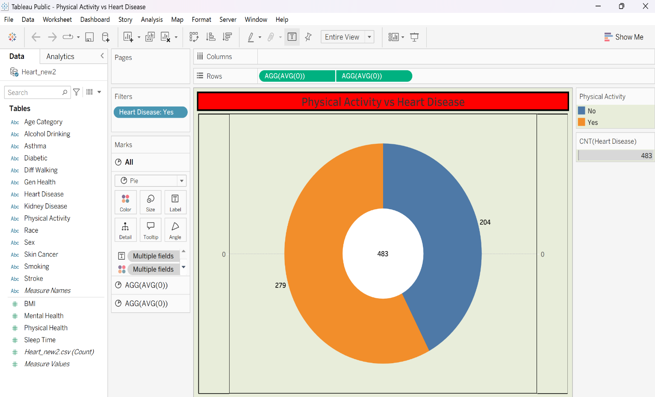
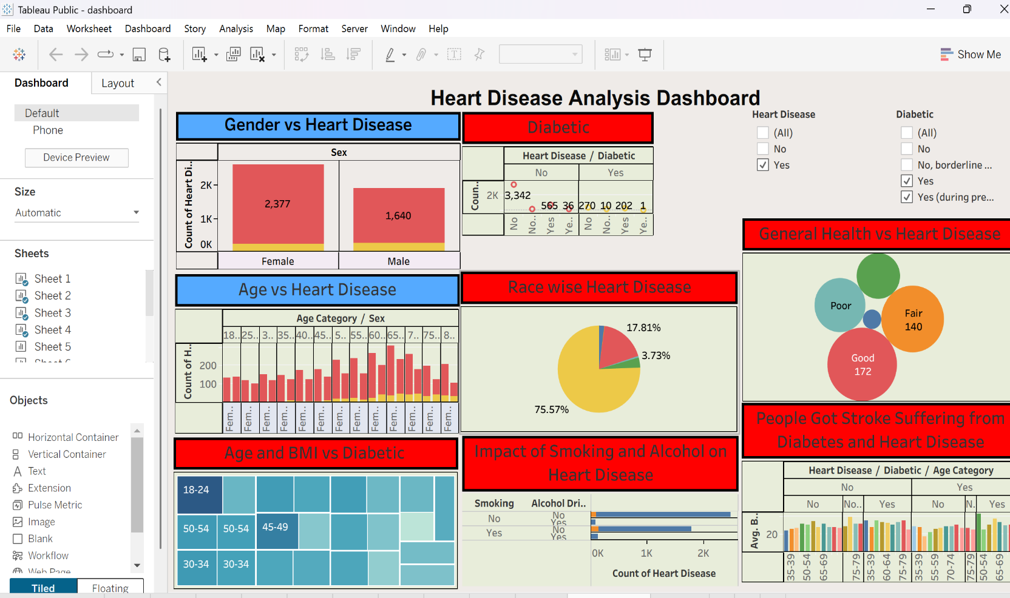
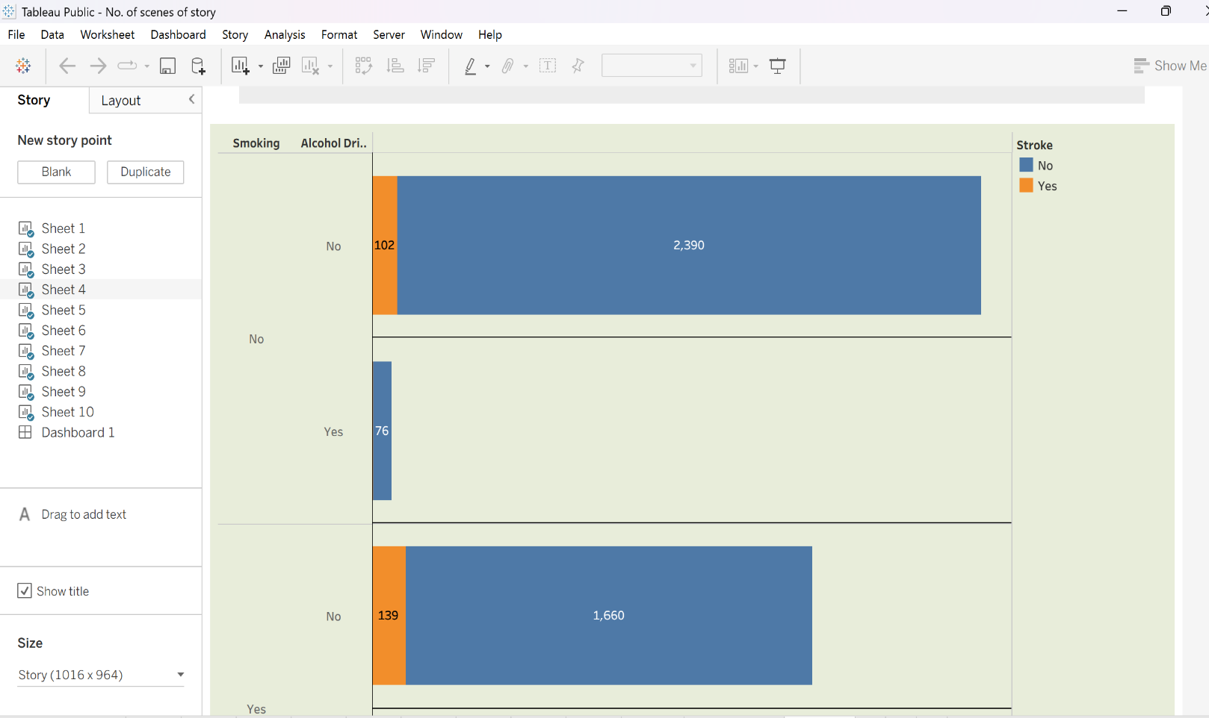
ADVANTAGES & DISADVANTAGES
Advantages
- Easy Healthcare Data Understanding
  - Converts complex heart disease datasets into simple and interactive visualizations, making healthcare analysis easier to understand.
- Improved Decision-Making
  - Helps healthcare professionals, researchers, and organizations make informed decisions using data-driven insights.
- Identifies Heart Disease Patterns
  - Reveals relationships between health factors, lifestyle habits, and heart disease occurrence through data analysis.
- Time-Saving Analysis
  - Automates data cleaning, SQL analysis, and visualization processes, reducing manual effort and analysis time.
- Accurate Data Analysis
  - Uses database queries and visualization techniques to provide reliable insights from healthcare data.
- Interactive Dashboards
  - Supports charts, graphs, filters, and dashboards in Tableau that improve user interaction and understanding of heart disease trends.
- Scalable System
  - Can handle large healthcare datasets and can be extended with additional patient information and analysis features.
- Supports Healthcare Research
  - Useful for medical research, academic studies, healthcare planning, and understanding disease risk factors.
- Cost-Effective Solution
  - Uses efficient tools such as MySQL Workbench and Tableau for database management and visualization, reducing the need for complex systems.
- Future Ready
- Can be enhanced with machine learning models for heart disease prediction, early risk detection, and advanced healthcare analytics.
Disadvantages
- Dependent on Data Quality
  - Incorrect, incomplete, or outdated healthcare data may lead to inaccurate analysis and misleading conclusions.
- Limited Prediction Capability
  - The current system mainly focuses on data analysis and visualization rather than real-time heart disease prediction.
- Requires Technical Knowledge
  - Users may require basic knowledge of SQL, databases, and visualization tools to modify or extend the system.
- Performance with Very Large Datasets
  - Extremely large healthcare datasets may require higher processing power and memory, which can affect system performance.
- Data Privacy Concerns
  - Healthcare data contains sensitive patient information and must be managed securely to protect privacy.
- Regular Data Updates Required
  - Healthcare trends and patient information change over time, requiring regular updates for accurate analysis.
- Limited Real-Time Monitoring
  - If static datasets are used, the system cannot provide real-time monitoring of patient health conditions.
- Visualization Interpretation Challenges
  - Users without healthcare or analytical knowledge may find it difficult to correctly interpret some charts and insights.
- Dependency on Database and Visualization Tools
  - The system depends on MySQL Workbench and Tableau availability for performing analysis and generating dashboards.
- Maintenance Requirements
- The database, dashboards, and related tools require regular updates and maintenance to ensure efficient performance.

CONCLUSION
The Heart Disease Analysis using MySQL Workbench and Tableau project demonstrates how data analysis and visualization techniques can transform large and complex healthcare datasets into meaningful and easy-to-understand insights. By applying data preprocessing, database management, SQL analysis, and visualization techniques, the project enables users to identify heart disease patterns, analyze health-related factors, and understand the relationships that influence cardiovascular health. The use of interactive visualizations such as charts, graphs, and dashboards makes complex healthcare information easier to interpret and supports effective analysis of disease trends.
The project successfully utilizes MySQL Workbench for storing, managing, and analyzing healthcare data through SQL queries, while Tableau is used to create interactive dashboards and visual reports. These technologies provide an efficient, reliable, and organized approach for processing healthcare datasets and presenting analytical results in a clear and user-friendly manner.
The developed system benefits healthcare professionals, researchers, students, and public health organizations by providing valuable insights into heart disease risk factors and patient health patterns. It helps users make informed, data-driven decisions by improving the understanding of factors associated with heart disease, supporting preventive healthcare strategies, and reducing the challenges of manual data analysis.
Overall, the Heart Disease Analysis using MySQL Workbench and Tableau project achieves its objective of converting raw healthcare data into meaningful visual information. It highlights the importance of data analytics and visualization in the healthcare sector and demonstrates how modern tools can support better understanding, planning, and decision-making. The project also provides a strong foundation for future improvements, including machine learning-based heart disease prediction, real-time patient monitoring, and advanced healthcare analytics.

FUTURE SCOPE
The Heart Disease Analysis using MySQL Workbench and Tableau project provides a strong foundation for analyzing and understanding healthcare data through database analysis and visualization techniques. Although the current system effectively analyzes heart disease datasets and presents meaningful insights, several enhancements can be implemented in the future to improve its accuracy, functionality, and usability.
One of the major future improvements is the integration of machine learning algorithms to predict the risk of heart disease based on patient health information and lifestyle factors. Predictive models such as classification algorithms can help identify high-risk individuals at an early stage and support healthcare professionals in making faster and more accurate decisions.
The project can also be enhanced by incorporating real-time healthcare data from hospitals, wearable health monitoring devices, and electronic health record systems. This will allow continuous monitoring of patient health conditions, provide updated insights, and improve the ability to detect potential heart disease risks in real time.
Another important enhancement is the development of an interactive web or mobile application using frameworks such as Streamlit, Flask, or other application platforms. This would enable healthcare users to upload new datasets, explore patient information, apply filters, and access analytical dashboards easily without requiring technical knowledge of databases or visualization tools.
Future versions of the project may also include advanced visualization features such as geographical health analysis, patient risk scoring, and comparative analysis across different regions and populations. Additional factors such as diet, genetics, medical history, and lifestyle patterns can be incorporated to provide a more comprehensive understanding of heart disease causes and prevention.
The system can further support cloud-based deployment, allowing secure storage of healthcare data and enabling authorized users to access dashboards and reports from different locations. Integration with artificial intelligence techniques can also provide personalized health recommendations and improve early disease detection.
In conclusion, the future scope of the Heart Disease Analysis using MySQL Workbench and Tableau project is extensive. By integrating machine learning, real-time healthcare data, artificial intelligence, cloud computing, and advanced analytics, the project can evolve into a comprehensive healthcare decision-support system that provides accurate risk predictions, personalized insights, and improved strategies for heart disease prevention and management.

APPENDIX
Dataset Link:
https://drive.google.com/file/d/1JWF9pcMDKv0TzBqbj9yP8Pzu0K6wlTJc/view?usp=sharing
GitHub Link:
https://github.com/Harinimachavarapu/heart-disease
Project Demo Link:
https://drive.google.com/file/d/1aZc7Im83S6832a4-dMArOk-9sO-hKedb/view?usp=sharing

